Sandra Gumoshabe

Coursework report
PRIMARY SCHOOL MANAGEMENT SYSTEM
This database manages student profiles, teacher information, academic subjects and fees bills thus creating order and easy storage.
The system is built using 6 related tables that is;
Teacher: Stores employee data (TeacherID is PRIMARY KEY).
Pupil: Stores demographics for all students (PupilID is PRIMARY KEY).
Subject: Academic courses linked to specific teachers (SubjectID is PRIMARY KEY, TeacherID is FOREIGN KEY).
Class: Standard academic levels (ClassID is PRIMARY KEY).
Enrolment: Shows when the pupils were enrolled in to the school (EnrollmentID is PRIMARY KEY, PupilID & ClassID are FOREIGN KEYS).
Fees: Accounts ledger tracking payments and balances per student (TransactionID is PRIMARY KEY, PupilID is FOREIGN KEY).

Database Created | Teacher Table
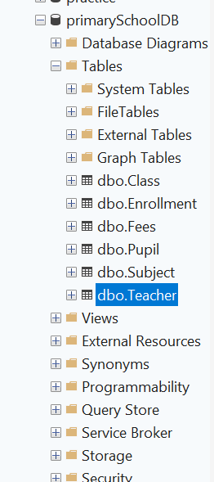 | 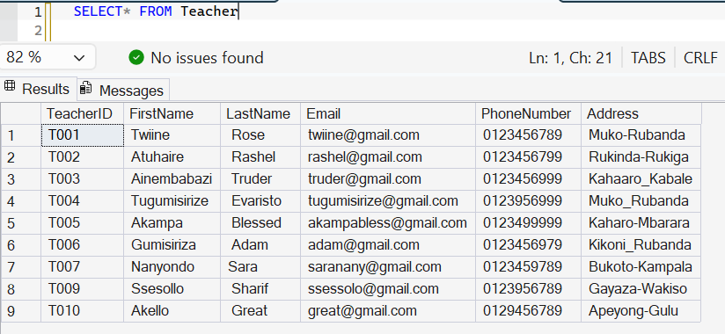

Tables created
pupil | Subject
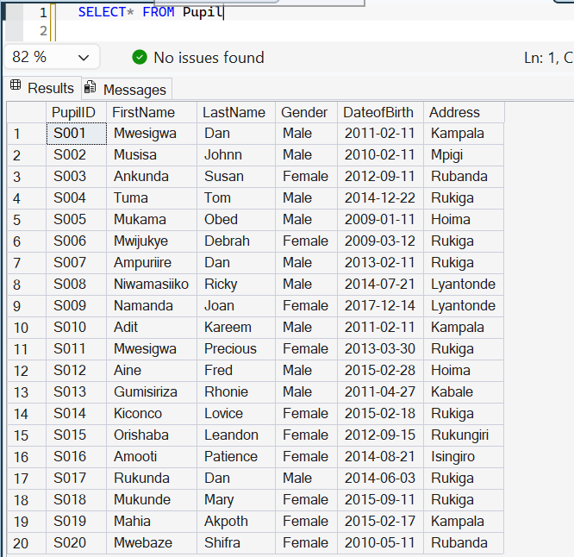 | 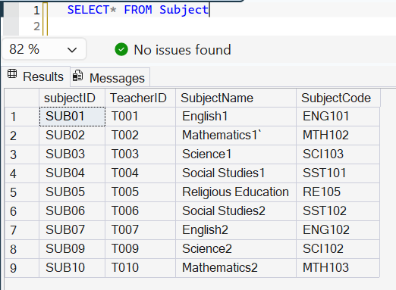

Fees | Enrollment
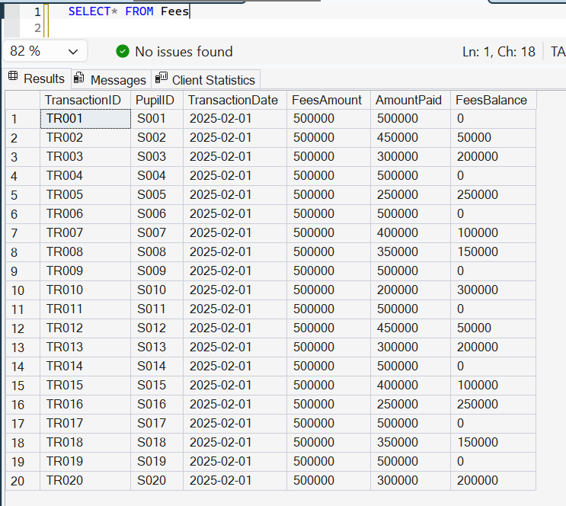 | 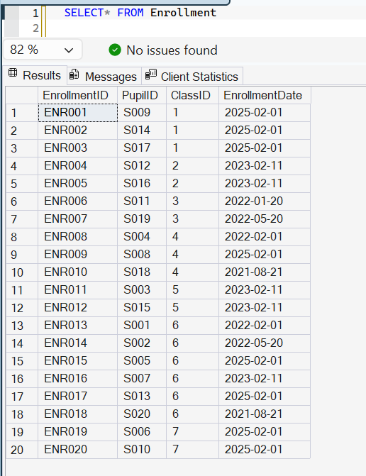

Class
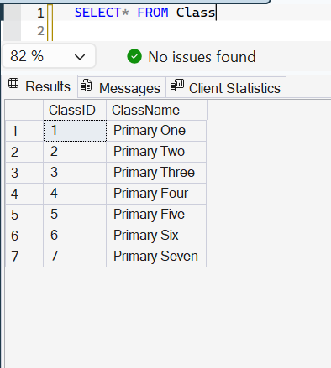

Inserted records
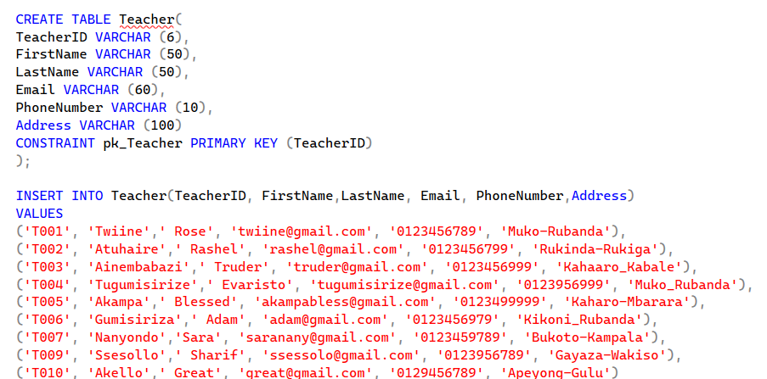 | 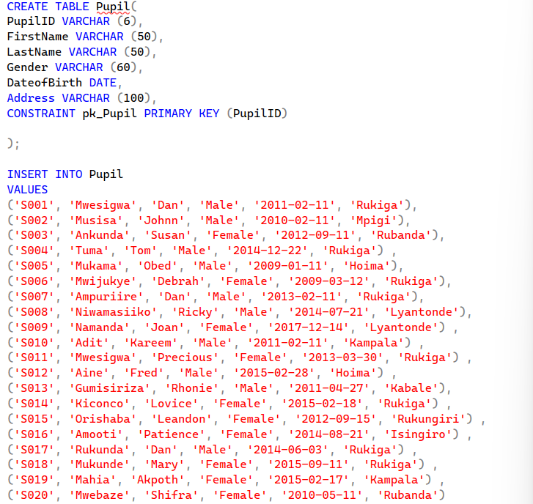
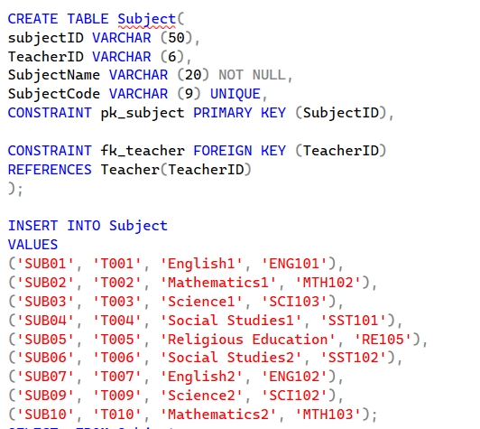 | 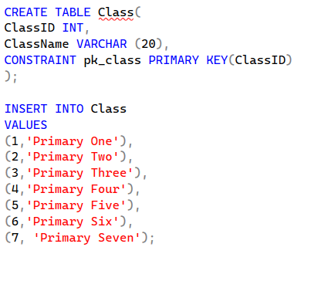
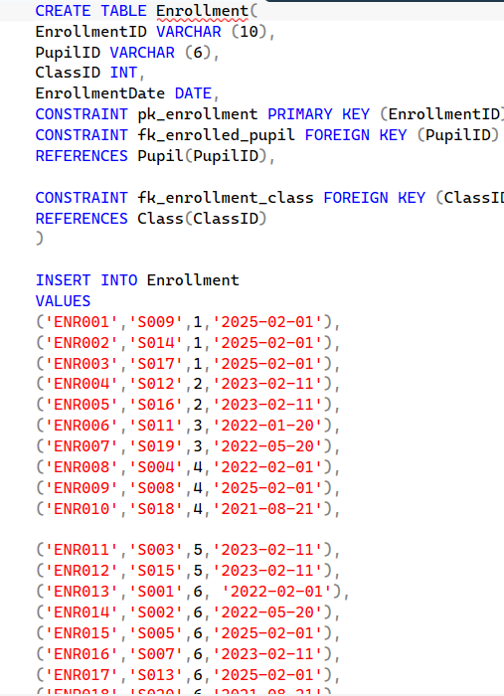 | 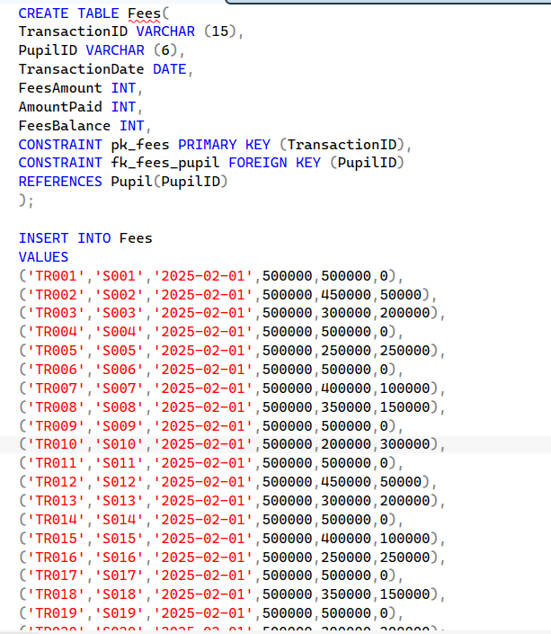

Query outputs
All records | WHERE
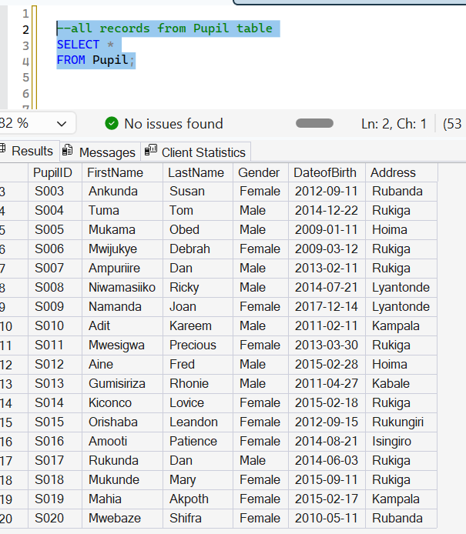 | 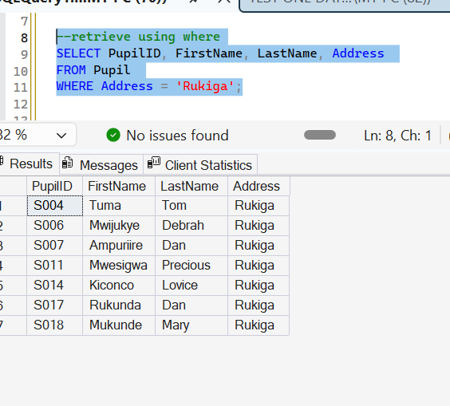
ORDER BY | COUNT()
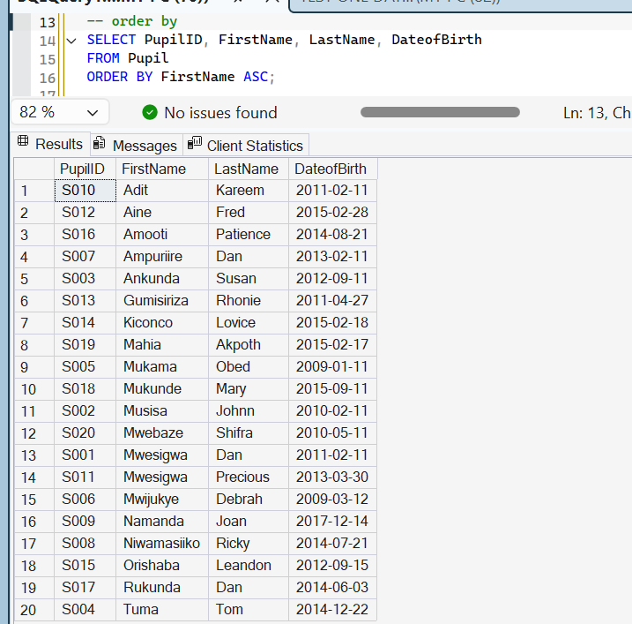 | 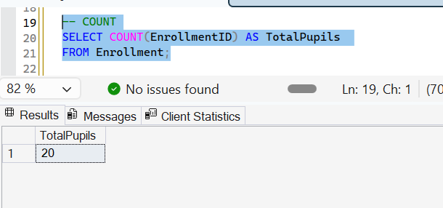
SUM() | AVG()
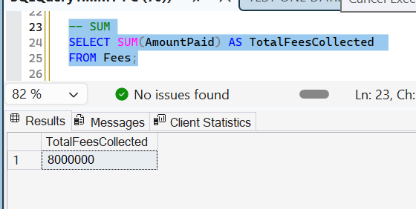 | 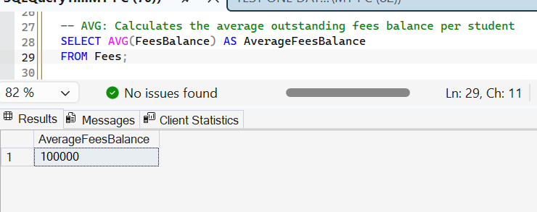
JOIN | UPDATE
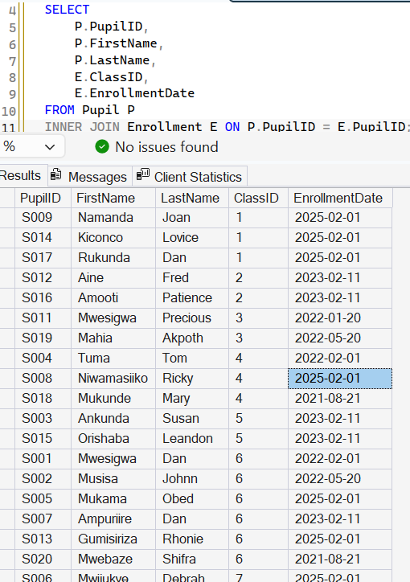 | 